Project Outline

| University Of Waterloo    **Plant Hydration System**  Design Document  Kushal Prajapati & Krish Prajapati  *ECE198*  David Lau  27 October 2024 |
| --- |

Table of Contents

1. Needs Assessment………………………………………………………….………………. 3

1.1 Client/Customer Definition ……………………….……………….…….… 3

1.2 Competitive Landscape ………………………….………………….………. 5

1.3 Requirement Specification ………….………………………….……….…. 6

1. Analysis .………………………………………………………………………………………. 9

2.1 Design …………….……….…….…………………………………………….… 9

2.2 Scientific or Mathematical Principles …..……………….……….……. 13

1. Costs ……………………………………………………………………………………..…… 17

3.1 Manufacturing Costs ……..………….………………………………...….… 17

3.2 Implementation Costs ……..…………………………………….……….… 19

1. Risks ……………………………………………………………………………….…………. 21

4,1 Energy Analysis ……..…………………………………………….……….… 21

4.2 Risk Analysis ……..…………………………………………….…………..… 23

1. Testing and Validation………….……………………………………………………….. 25

5.1 Test Plan ……..………………………………………….….………………..… 25

1. References…………………………………………………………………………………… 28

# 1. Needs Assessment

## 1.1 Clients Definition

Many students in university dorms and rooms enjoy keeping plants in their rooms for various reasons, including decoration, stress relief, and improving air quality. According to a study by the Identity Realization research group at the University of Exeter [1], research has shown that indoor plants can help increase productivity by up to an astonishing 47%. It has also been analyzed that plants help give a 20% percent boost in memory and concentration. There are many reasons for the effect, including the smell of plants and flowers, their look, as well as how they help improve the oxygen levels within a room by absorbing the carbon dioxide and producing oxygen.

However, students also often struggle to properly take care of their plants primarily due to:

* Busy Academic Schedules
* Lack of gardening knowledge
* Inconsistent room environments

Students often have a hard time managing school time, teams, family responsibilities, and other priorities, often making maintaining plants hard and easy to forget. In addition, most dorm rooms have varying light and humidity levels, making it challenging and sometimes even stressful to take care of plants, especially with inadequate experience [2]. All of these factors can make plants more of a difficulty to manage rather than helpful. In addition, this lack of proper plant care may result in dead or unhealthy plants, which would further frustrate students and waste resources.

**Demographic:**

The customer base consists primarily of university students residing in dormitories and primarily at the University of Waterloo campus. The students often range from 18 to 25 years old, and many are in their early stages of adulthood, transitioning from their family environments to independent living. As university students, they generally seek ways to create a welcoming, comfortable space in dorm rooms, which is known to increase satisfaction and a sense of belonging in the campus community[3]. Plants are a natural choice for this demographic, as they add aesthetic and psychological benefits without requiring excessive space or resources.

**Economic:**

Many students live on tight budgets. Limited financial resources mean that these individuals often look for affordable solutions to decorate their space and improve their environment [4]. This economic constraint drives the need for a plant maintenance solution that is cost-effective, both in terms of initial purchase and ongoing maintenance, primarily since students don’t face unnecessary financial burdens.

**Lifestyle:**

University life incorporates busy schedules and constant multitasking. Students are often balancing a mix of academic coursework, extracurricular activities, part-time jobs, and social engagements. This lifestyle frequently leaves little time for additional responsibilities like plant care. However, students’ interests in well-being and mental health align with the benefits that indoor plants offer, such as stress reduction and improved focus [5] . Therefore, given their time constraints, students require a low-maintenance plant solution that doesn’t add undue stress to their routine.

## 1.2 Competitive Landscape

There are 3 main solutions towards helping students take care of their plants, but they each have their shortcomings:

* Smart Plant Care Systems
* Mobile Plant Care Apps
* Automated Hydroponic Systems

1. Smart Plant Care Systems (e.g., Click & Grow)

Smart Plant Care Systems, such as Click & Grow smart indoor garden, are designed to simplify plant care through automation of the entire process, ideal for users with busy schedules, inconsistent indoor environments, or limited gardening knowledge [6]. They automate watering, lighting, and nutrient delivery completely, using LED lights and sensors to maintain optimal growing conditions even in dorms. For beginners, pre-seeded pods and clear care instructions make plant care accessible. However, these systems’ usually have a high cost (ranging from $100 to $200), can incorporate limited plant variety, and are dependent on replaceable pods, adding ongoing expenses, which might be challenging for students on a budget. Additionally, it takes over too much of the plant care process, not contributing to the personal connection that comes from watering and taking care of the plant manually.

2. Mobile Plant Care Apps (e.g., Planta)

Mobile Plant Care Apps, such as Planta, are designed to assist users in plant care by offering reminders, lighting analysis, watering schedules, and tips on plant health. To support busy students, they help send notifications for essential tasks like watering and sunlight requirements, making plant care easier to remember [7]. Some of these apps also analyze room lighting in some versions, helping users find optimal plant placement for growth, and provide a plant identifier and care guide to help beginners understand plant needs. However, these apps rely on user input for plant details, which can be time-consuming, and requires smartphone access, which might limit accessibility. Additionally, Planta lacks features such as checking moisture levels and lighting conditions, making it less accurate or insightful than physical systems. It doesn't stop users from over watering or other features like alarms within accurate times.

3. Automated Hydroponic Systems (e.g., AeroGarden)

Hydroponic Systems, such as the AeroGarden, are indoor hydroponic systems that grow plants without soil, using water-based nutrients and LED lighting for efficient indoor cultivation. It automates care with timers for light and nutrient delivery, making it ideal for busy students who can’t tend to plants frequently. The enclosed design provides consistent growing conditions, reducing dependence on room lighting and humidity, while guided setup instructions support beginners in achieving successful growth [8]. However, AeroGarden’s high upfront cost (starting at $150) may make it less accessible towards students, and while less labor-intensive than traditional gardening, the system still requires occasional cleaning. Additionally, it’s most effective for growing small herbs and vegetables, limiting plant variety. One drawback of these systems are that they often require other components or nutritional food which make the process time consuming and a bit stressful for university students, as well as making it more of a subscription, adding to the monthly cost. Similar to the SmartPlant systems, it also takes over too much of the plant care process, not contributing to the personal connection that comes from watering and taking care of the plant manually.

## 1.3 Requirement Specification

### Sound (Alarm System)

**Functional Requirements:**

The alarm must notify the user when the soil moisture drops below a set threshold or when light levels are lower than normal with an audible alert. According to the Hearing Health Foundation guidelines, an audible alert should be between **60 dB and 70 dB** (at a distance of 1 meter), which is sufficient for attracting attention during typical household activities without causing a nuisance [9].

According to studies in PubMed Central [9] on the impact of light on adults, **moderate light levels around 700 - 800 lumens** are sufficient to draw attention and prompt a response without being intense enough to fully wake someone from sleep. Therefore, the alarm’s LED lights should produce **800 lumens,** which is comparable to a standard 60-watt incandescent bulb, ensuring visible light output even in bright environments.

**Technical Requirements:**

The alarm must produce a sound level of at least 60 dB at a distance of 1 meter [10].

According to the manufacturer, Led Lights Unlimited, The LED must operate at **2-3 volts** to prevent excess heat and voltage spikes which should produce at least **800 lumens** of light, ensuring sufficient visibility even in well-lit environments.

**Safety Requirements:**

Studies by the Hearing Health Foundation indicate that sound must not exceed 70 dB to prevent potential hearing damage.

The alarm system’s LEDs must operate at 2-3 volts to prevent excess heat[11].

Light (Lux Measurement)

**Functional Requirement**:

According to an article by Vegetableacademy, the system should continuously monitor the amount of light the plant receives throughout **every hour** to provide sufficient data for determining whether the plant has received adequate light. It should compare this data with the recommended daily light exposure for the specific plant type with a tolerance range of **5%** to ensure the plant gets adequate light for healthy growth[12].

**Technical Requirement**:

According to an article by Jbdconcepts , indoor plants typically thrive in light levels ranging from **500 to 2,000 lux**, depending on the plant type. Therefore, the light sensor should measure between **0-10,000 lux** (sufficient to cover indoor lighting to bright daylight exposure), with daily tracking for 12 hours [13]. Furthermore, the sensor must function effectively under outdoor lighting conditions and be able to withstand temperatures between **-30°C to 40°C as** according to data from the University of Waterloo, temperatures in Waterloo range from -20°C to 30°C.

**Safety Requirement**:

Light measurement accuracy should be ±5% of the light meter’s to ensure the readings are reliable without risking incorrect notifications.

The entire system must be enclosed to protect it from water, and no wires should be left exposed. Furthermore, it should be able to withstand temperatures between -30°C to 40°C[14].

### Water (Soil Moisture Measurement)

**Explaining the unit of percentages:**

Water is a good conductor of electricity, while dry soil is not. As the soil’s water content increases, its resistance decreases, allowing more current to pass through the sensor. The sensor outputs an **analog voltage signal (usually between 0V and 3.3V or 5V)**, which is converted to digital percentage, that corresponds to the soil moisture level.

**Functional Requirement**:

The system must accurately measure the soil’s moisture content and differentiate between dry, moist, and oversaturated soil conditions with the correct calibration. The moisture data should guide plant care by providing real-time feedback on hydration levels **every hour.**

According to an article by Acurite, the system must stop the alarm once the soil moisture exceeds **45%**, ensuring that the user does not overwater the plant. This ensures healthy plant care and prevents excessive watering [15] . Furthemore, the soil moisture sensor must function safely within a soil moisture range of **20-80%**, preventing malfunctions or sensor degradation in both drier and wetter soil conditions.

**Technical Requirement**:

According to the manufacturer of the sensor, Sunfounder, the soil moisture sensor should measure water content as a percentage from **0-100%**, with the analog voltage (V) accurately measuring voltage when dry or over-saturated. The alert will trigger when moisture falls below **30-40%** (depending on the plant type). With the conversion to a digital value, the permitted deviation from a commercially available soil moisture tester is no more than **5%** based on sensor comparison tests . Accuracy will be verified using a standard soil moisture meter.

**Safety Requirement**:

To ensure long-term durability, the soil moisture sensor must be **PCB-coated** to protect it from corrosion caused by prolonged exposure to moisture. This coating helps combat the typically short lifespan of soil moisture sensors in a moist environment, ensuring ongoing accuracy. Furthermore, as the light sensor, it should be able to withstand temperatures between -30°C to 40°C.

### **LCD Display Update Rate**

**Functional Requirement**:

The LCD must update sensor readings once ever**y 60 minutes (i.e., once per hour)**. This interval provides a reasonable time to update info while minimizing power consumption for both the sensors and the display. Low-power LCD displays usually consume between **10-20 mW** during operation, and periodic updates (once every hour) can reduce overall power usage.

Constantly measuring moisture and light levels can also degrade sensor performance over time[16], and research suggests that less frequent updates can help extend sensor life by up to **20-30%** in low-power environments, based on the industry data provided from low-power LCD product specifications [17] .

**Technical Requirement**:

The Low-power LCD display must consume between **10-20 mW** during operation, in every hour, and must be visible for 5 minutes for the user to see. According to ynsible.com[18], many commercially available low-power displays operate within this range, making it a widely accepted standard for energy-efficient designs. Furthermore, **five minutes** provides enough time for a user to check the moisture and light levels without rushing or having to react immediately after the update.

# 2. Analysis

## 2.1 Design

The Plant Care Monitoring System utilizes two STM32 microcontrollers to effectively monitor soil moisture and light levels for plant care. The system is divided into two main parts/boxes: The first box contains a microcontroller that collects data from a capacitive based soil moisture sensor and a light sensor (LTR-329). This information is then sent to the second box through a wired connection. The second box contains another microcontroller that processes this information, comparing it to predefined thresholds, and provides alerts through an LCD display and alarm system. All in all, the system consists of two STM32 microcontrollers, a capacitive based soil moisture sensor, a light sensor, an LCD display, an LED, a buzzer, wiring, resistors and breadboards for connections, and a power supply. These components were used since they fit our technical, safety and function requirements [19].

To use the system, the user should take the first box and start positioning the soil moisture sensor below the soil in the plant pot and placing the light sensor on top of the pot to measure sunlight exposure. Next, place the second box where you want your alarm to go off and check the moisture levels using the LCD, within a 1-meter range for easy visibility.

Once the system is powered and turned on, the moisture and light levels should start tracking and updating every hour. **Moisture(%) should be represented by (V_measured-V_dry) / (V_wet-V_dry)*100** by calculating the resistance(Ω) acting on the sensor. If the light exposure is insufficient, the alert mechanism should activate the LED and buzzer if the moisture level falls below the threshold. The LED should flash and the buzzer should sound in either case to alert the user. Once the moisture level returns to normal, the alert system should be deactivated. **The LCD should always display moisture (in %) and light intensity (in lux) updating every hour.**

Alternatives

Several alternative technical solutions were considered for the plant care monitoring system. One option was to use a single microcontroller with integrated sensor support. However, managing multiple sensors on one unit can create power spikes and reduce efficiency, with a potential draw of up to 500mA in active mode when handling several sensors at once [20].

Another alternative was to implement a wireless communication system, such as using Bluetooth or Wi-Fi modules to connect the sensors. While this approach could allow for remote monitoring and control via a smartphone app, it has an average consumption of ~15mA when actively transmitting, but it introduces connectivity issues and potential latency (up to 100ms). Wi-Fi, though fast, consumes significantly more power (~70-300mA), increasing overall system energy demands. Both options would enable remote monitoring but were ultimately rejected due to added power and complexity concerns [21].

Finally, Time Domain Reflectometry (TDR) and Frequency Domain Reflectometry (FDR) sensors were considered but were unsuitable due to costs (~$150 per sensor), long response times (up to 2 seconds), and the need for complex calibration, which would complicate real-time monitoring but consequently increase the chance of failure[22] .

The chosen solution with two STM32F401RE microcontrollers (each drawing ~100mA in active mode, ~20µA in sleep) splits data collection and processing, maintaining functionality without power overload. This setup keeps peak power below 500mW, a key requirement for the system, with each microcontroller handling separate tasks to streamline troubleshooting and processing, enhancing both power efficiency and manageability[23].

Design Schematic

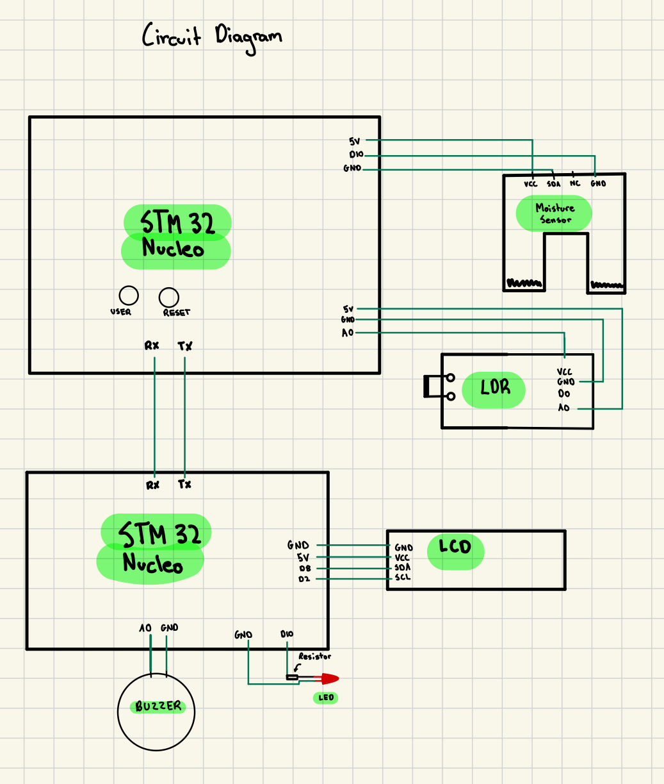

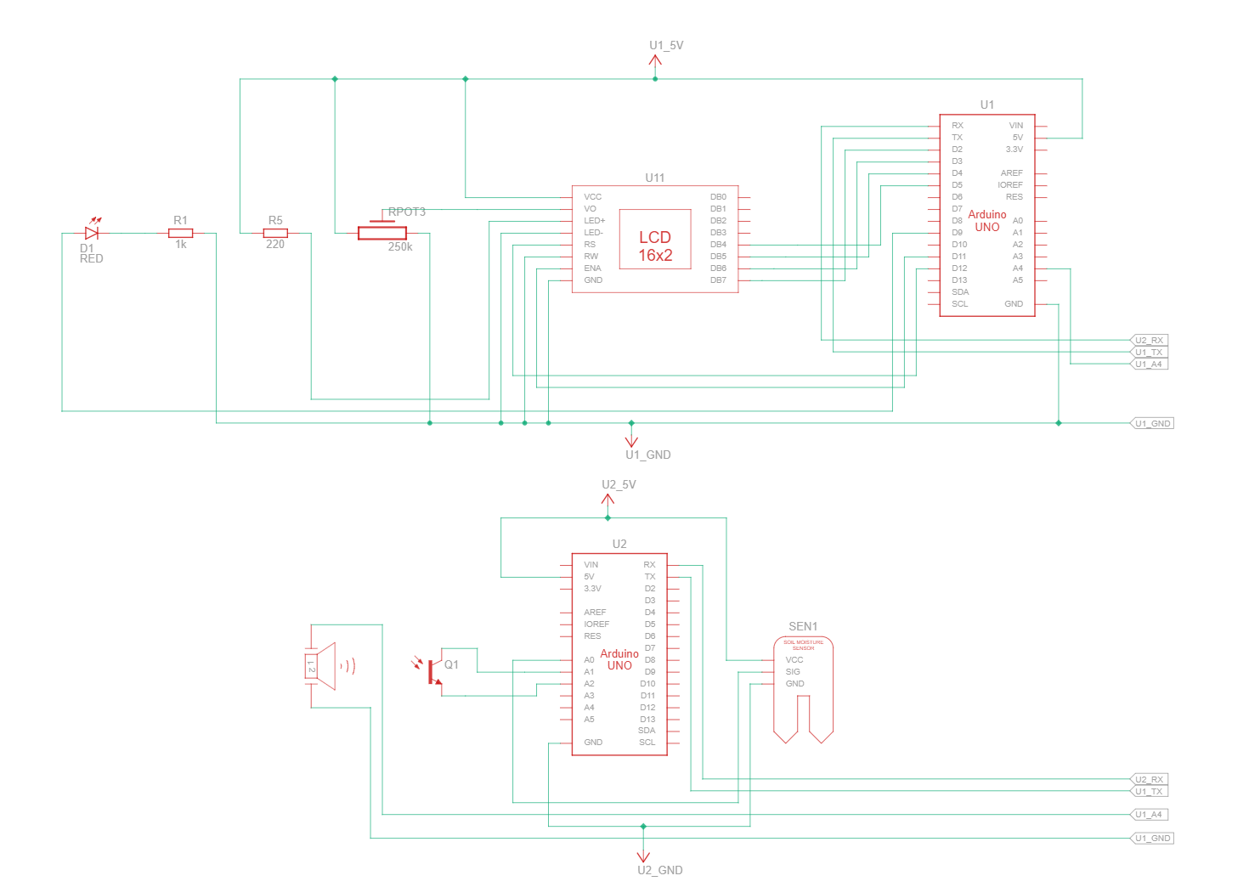

Software Design Outline:

To implement the design by integrating the components’ input and output, we use the following code skeleton:

Initialize Soil_Moisture_Sensor

Initialize Light_Sensor

Initialize Communication_With_MCU2

loop:

// Read sensor data

moisture_level = Read(Soil_Moisture_Sensor)

light_level = Read(Light_Sensor)

// Send data to Microcontroller 2

SendData(moisture_level, light_level)

// Wait for one hour

Wait(1 hour)

end loop

// Microcontroller 2 (MCU2)

Initialize LCD_Display

Initialize LED

Initialize Buzzer

Set Thresholds(moisture_threshold, light_threshold)

loop:

// Receive data from Microcontroller 1

(received_moisture, received_light) = ReceiveData()

// Display current values on LCD

DisplayOnLCD(received_moisture, received_light)

// Check moisture level

if received_moisture < moisture_threshold then

ActivateAlarm() // Flash LED and sound Buzzer

end if

// Check light level

if received_light < light_threshold then

ActivateAlarm() // Flash LED and sound Buzzer

end if

// Wait for the next data reception

Wait(1 hour)

end loop

// Function to activate alarm

Function ActivateAlarm()

Flash(LED)

Sound(Buzzer)

end Function

## 2.2 Technical Analysis

### Ohm’s Law for Voltage Measurement

Principle: Ohm’s Law states that the current through a conductor between two points is **proportional** to the **voltage** across the two points. In addition, it has to be **inversely proportional** to the **resistance**. This can also be applied to the soil moisture/hydration sensing, where the resistance of the sensor would change based on its moisture content. [24]

*Formula: V=I*R*

**Voltage (V)**:

* This is the potential difference applied across the soil moisture sensor. As soil moisture changes, so does the sensor's resistance, directly impacting the measured voltage. By reading the voltage level, we can infer the soil's moisture content; a higher voltage reading typically indicates drier soil (higher resistance), while a lower reading indicates moist soil (lower resistance)
* The voltage across the soil moisture sensor depends on the input voltage supplied to the circuit, typically from a microcontroller (e.g., 3.3V or 5V).
* If using a 5V supply and a voltage divider circuit with the soil as one of the resistive elements, the output voltage would vary between nearly 0V (very high moisture) to almost 5V (very dry soil) depending on the soil's resistance

**Current (I)**:

* The current in the circuit is determined by both the voltage supplied to the sensor and the resistance within the soil. Since current is directly related to the moisture level, the current value will fluctuate based on moisture-induced resistance changes.
* Using Ohm’s Law, the current can be calculated by rearranging the formula: I=V/R
* For example, with a 5V supply and wet soil resistance of 500Ω, the current would be: I=5V/500Ω=0.01A (
* With dry soil (10kΩ resistance), the current would drop significantly: I=5V/10000Ω=0.0005A

**Resistance (R)**:

* The soil acts as a variable resistor; its resistance changes with moisture content. Drier soil has higher resistance, whereas moist soil allows better conductivity, decreasing resistance. This resistance is crucial, as it modulates the circuit's voltage and current to provide accurate moisture readings.
* **Wet Soil:** Lower resistance, potentially in the range of a few hundred ohms (e.g., 200-500Ω).
* **Dry Soil:** Higher resistance, often in the range of several thousand ohms (e.g., 10kΩ or more).
* To determine these values precisely, you would need to test the sensor with your specific soil and moisture levels, as resistance values can vary based on soil composition and probe placement.

To see the power of each component and make sure that each component is given an adequate supply of power without overvolting, we would utilize the ohm’s law. As a result, we can put adequate resistance and prevent any of the components from heating up, or in a worse scenario, causing a fire, raising a risk to safety.

Choosing Resistor Values for Safety and Calibration Utilizing Ohm’s Law

* Series Resistor: A fixed series resistor (e.g., 1kΩ - 10kΩ) can limit current, protecting the circuit in the event of sudden resistance drops due to high moisture levels.
* Voltage Divider Resistor: In a voltage divider circuit, an additional resistor can help scale the output voltage to remain within the safe input range of the ADC (Analog-to-Digital Converter) on the microcontroller.

### Interpolation of moisture values:

Standard: Since the sensor of the soil hydration outputs an digital voltage, we can use it to correspond/interpolate the values of hydration:

* Dry Soil: Higher resistance, lower current, resulting in a higher voltage
* Wet Soil: Lower resistance, higher current, resulting in a lower voltage

We can use the values to than interpolate the moisture % using the formula below using the ADC value (Analog to Digital) and output the readings:

* ***Moisture(%)= (V_measured-V_dry) / (V_wet-V_dry)*100***

This formula is essentially a linear interpolation between the dry and wet conditions, and thus it is estimating a value within the two conditions. Essentially the first part of the equation, (V_measured-V_dry) / (V_wet-V_dry) will give us a proportion between 0(completely dry) and 1(fully wet). The percentage that will be outputted will be the main value to evaluate the hydration of the plant, and if it reaches a certain threshold, between 10% and 40% percent[25], the system can output that the plant is healthy, or else if it doesn’t pass the admissible values range, we can alert the system. [26]

### Human-Centered Design (ISO 9241-210) :

Human-Centered Design Standard focuses upon designing systems that have a user-centered approach. It ensures that the systems are easy to use, understand, and interact with for the user. It focuses on creating products that meet the needs and expectations of users, ensuring that they can interact with the system efficiently, effectively, and intuitively. [27]

**For our implementation in our project, we will utilize multiple sections:**

Section 4.2: The design is based upon an explicit understanding of users, tasks and environments

* Description: The section focuses on the significance of understanding the end users, and what tasks they perform, and the environment they will interact with in our system. As a result, we can specify the context of use and focus solely on our end users.
* The section states: “The extent to which products are usable and accessible depends on the context, i.e. the specified users, having specified goals, performing specific tasks in a specified environment”.
* In our product:
  + Our users are students living in dorms that do not have must experience with plant care
  + Our environment are dorm rooms, which are small indoor spaces with limited light
  + The tasks that our product will perform are to monitor plant health (moisture, light values), and then reacting based on system alerts

Section 6.3: Specifying the user requirements

* Description: This section focuses on the importance of defining the user’s needs and expectations in the entire design process
* The section states: “ For human-centered design, these user requirements must be explicitly addressed in relation to the intended context of use”.
* Using this standard, we must ensure that our user’s key requirements are prioritized. Specifically for the product we are creating, the follow requirements are key and must be met:
  + The system should be easy to understand and use without technical expertise
  + The system should be easy to handle and utilize
  + The system must be safe to use
  + The system must effectively and accurately monitor the health of the plant
  + The alerts must be clear and actionable (lights or notifications), without requiring complex instructions

Section 6.4: Producing Design Solutions

* Description: Design solutions must be created with the user's requirements and context of use in mind.
* For our project, we will be specifically implementing this section through:
  + Creating an interface that will provide feedback accurately
  + Our interface will use simple instructions or visual cues such as a traffic light system for moisture (green for healthy, red for water needed), and a light indicator that dims or brightens depending on how much light the plant is receiving

Overview of how HCD (human-centered design) standards will be applied and benefit the project:

Benefits:

* Increased usability of our product
* Higher user satisfaction

Overall, by following the guidelines by ISO on human centered design, we will ensure that the design prioritizes the usability and satisfaction of students first, as they are our primary client. We will tailor our product to our users' specific context of use by making sure that the user interface and interactions are as stress-free and intuitive as possible. This standard will ensure that our alerts, sensor readings, and interface are intuitive, concise, and our entire system is designed with the students’ limited time and stress levels in mind. We want to ensure that the plants stay healthy without them becoming a chore, and that inexperienced plant owners can have the confidence in knowing their health and status. As a result, our product can be more beneficial and focused around students, and resultantly gain more popularity and success.

# 3. Costs

## 3.1 Manufacturing Costs

| Component | Manufacturer | Distributor | Cost |
| --- | --- | --- | --- |
| STM32 (Active Mode) | STM Electronics: Chemin du Champ-des-Filles 39  Plan-les-Ouates,1228, Geneva,Switzerland  Phone:+41 22 929 29 29  [28] | W-Store: 200 University Ave W, Waterloo, ON N2L 3G1  [35] | $50 + tax = $56.50 |
| STM32 (Sleep Mode) [5] | STM Electronics: Chemin du Champ-des-Filles 39  Plan-les-Ouates,1228, Geneva,Switzerland  Phone:+41 22 929 29 29  [28] | W-Store: 200 University Ave W, Waterloo, ON N2L 3G1  [35] | $50 + tax = $56.50 |
| Capacitive Soil Moisture Sensor ST0160 | Sunfounder Electronics: 43 Laner Rd, Longgang, Shenzhen, Guangdong Province, China, 518117  [29] | Digikey - Address:  701 Brooks Ave. South  Thief River Falls  MN 56701  UNITED STATES  [36] | $10.80 + tax = $12.20 |
| Buzzer (Piezo) | Murata Electronics:3330 Cumberland Blvd., SE, Suite 700, Atlanta, GA 30339, USA  [30] | Digikey - Address:  701 Brooks Ave. South  Thief River Falls  MN 56701  UNITED STATES  [36] | $1.03 + tax = $1.16 |
| LED (single) | OptoElectronics: 885 Woodstock Rd. Ste. #430-521 Roswell, GA 30075  [31] | Digikey - Address:  701 Brooks Ave. South  Thief River Falls  MN 56701  UNITED STATES  [36] | $0.25 + tax = $0.28 |
| Small LCD Display (HD44780) | Newhaven Display: 2661 Galvin Ct, Elgin, IL 60124, United States  [32] | Digikey - Address:  701 Brooks Ave. South  Thief River Falls  MN 56701  UNITED STATES  [36] | $18 + tax = $20.34 |
| Light Sensor (LTR-329) | Lite-on: No. 392, Ruiguang Rd, Neihu District, Taipei City, Taiwan 114  [33] | Digikey - Address:  701 Brooks Ave. South  Thief River Falls  MN 56701  UNITED STATES  [36] | $3 + tax = $3.39 |
| Jumper Wires M to M | Adafruit Industries: 39th Street, Ste 1905CC, Brooklyn, NY 11232  [34] | Digikey - Address:  701 Brooks Ave. South  Thief River Falls  MN 56701  UNITED STATES  [36] | $1 + tax = $1.13 |
| USB A Male to Mini- USB B Male | STM Electronics: Chemin du Champ-des-Filles 39  Plan-les-Ouates,1228, Geneva,Switzerland  Phone:+41 22 929 29 29  [28] | W-Store: 200 University Ave W, Waterloo, ON N2L 3G1  [35] | Included as part of Arduino Kit |
| Breadboard Term Strip | Adafruit Industries: 39th Street, Ste 1905CC, Brooklyn, NY 11232  [34] | Rigidware: 200 University Ave W, Waterloo, ON N2L 3G1  [37] | $4 + tax = $4.52 |
| 290 Ohm Resistors | Adafruit Industries: 39th Street, Ste 1905CC, Brooklyn, NY 11232  [34] | Rigidware: 200 University Ave W, Waterloo, ON N2L 3G1  [37] | $1 + tax = $1.13 |

## 

## 3.2 Implementation Costs

Installation Manual

1. Take all components out of the box, including the alarm system and the sensor system.
2. Set up the sensor system by placing the first box containing the microcontroller with the soil moisture and light sensors on one side of the plant pot
3. Insert the soil moisture sensor into the soil and place the light sensor at the top of the pot
4. Set up the alarm system placing the second box containing the microcontroller, LCD display, LED, and buzzer within a 1-meter range from the plant pot for visibility
5. Plug the USB cable of each STM32 board into an appropriate power source
6. Ensure that all pins and wires are securely connected on the breadboards as they may come loose during delivery
7. Power on the system and check that the LCD display shows a prompt to start

User Guide

1. Ensure the soil moisture sensor is in the soil, with the light sensor placed on the soil surface for optimal sunlight measurement.
2. Adjust the LCD display's angle for easy readability.
3. Connect bot (alarm and sensor) boxes to power
4. Turn on both (alarm and sensor) boxes
5. The moisture reading will automatically calculate as a percentage using internal formulas
6. Check Light Level: The LCD will display light intensity in lux, updated every hour.
7. Set Thresholds: Configure the threshold values for moisture and light levels in the program as per plant care needs.
8. When moisture is low or light is insufficient:

* The LED will flash.
* The buzzer will sound to alert the user.

1. Once moisture and light levels return to normal, the alert system will deactivate, and only current readings will display on the LCD.
2. Disconnect the power supply when moving or changing the position of the system.

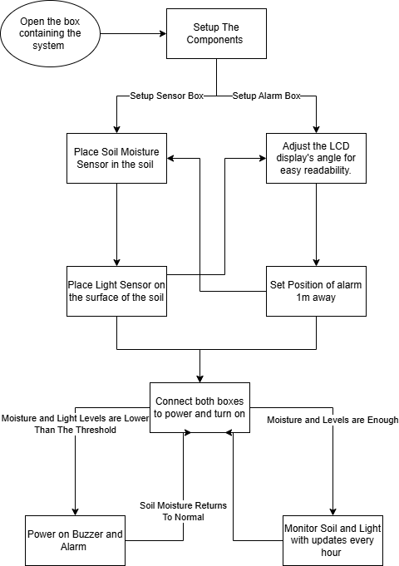

# 4. Risks

## 4.1 Energy Risks

The accuracy of the power and energy are not accurate, as they do not account for the program/code that the MCU faces or the energy utilization of all the devices on the microcontrollers. Consequently, our analysis is done to see the maximum power and energy our system will create, if all devices are active [38].

Power = v * a

**Maximum Power Output (Active Mode):**

STM32F401RE microcontrollers generally don’t have significant energy storage capabilities beyond what capacitors may hold temporarily. Each component (microcontrollers, sensors, LCD, LED, buzzer) primarily consumes power actively without retaining stored energy.

1. STM32F401RE Microcontroller [39]

- Active Mode: 3.3V, 100mA (Maximum Current)

- P = 3.3V x 100mA = 0.33W

- Sleep Mode: 3.3V, 20µA

- P = 3.3V x 20mA = 0.066mW

For two STM32 boards in active mode:

- 2 x 0.33W = 0.66W (660mW)

2. Soil Moisture Sensor [40]

- Active: 3.3V, 20mA (Maximum Current)

- P = 3.3V x 20mA = 66mW

- Off: 0W

3. LCD Display [41]

- Active (5 minutes every hour, backlight disabled): 5.5 V, ~1.6mA (Maximum Current)

- P = 5.5 V x 1.6 mA = 9mW

- Off: 0W

4. Light Sensor (LTR-329) [42]

- Active (hourly readings): 3.3V, 100µA (Maximum Current)

- P = 3.3V x 100mA = 0.33mW

- Off: 0W

5. Buzzer [43]

- Active (for alarms): 3.3V, 10mA (Maximum Current)

- P = 3.3V x 10mA = 33mW

- Off: 0W

6. LED (Status Indicator with 290 Ohm Resistor) [44]

- Active: 3.3V, 10mA (Maximum Current)

- P = 3.3V x 10mA = 33mW

- Dimmed: 3.3V, 2mA

- P = 3.3V x 2mA = 6.6mW

**Power Consumption:**

If the system’s energy consumption must stay below **500mJ (0.5J)** at any point in time, each component's usage must be adjusted to meet this constraint.

**Current Peak Power**: From the previous calculations, we found the peak power for each component:

1. Two STM32 microcontrollers: 660mW
2. Soil moisture sensor: 66mW
3. LCD: 9mW
4. Light sensor: 0.33mW
5. Buzzer: 33mW
6. LED: 33mW

Total peak power = **801.33mW**, which exceeds 500mJ when sustained over a second.

**Our Solution: Staggered Activation**: To ensure the system does not exceed 500mJ at any time, staggered activation can be implemented. In this way, we only activate only one or two high-power components at a time, keeping cumulative power within the 500mW threshold at any point.

For example:

1. **Minute 1**: STM32 Microcontroller 1 and soil moisture sensor (0.33W + 0.066W = 0.396W, below 500mW)
2. **Minute 2**: STM32 Microcontroller 2 and LCD (0.33W + 0.009W = 0.339W)
3. **Minute 3**: Buzzer and LED (0.033W + 0.033W = 0.066W)
4. **Minute 4**: Light sensor only (0.00033W)
5. **Minute 5**: Rest or low-power checks

Utilizing this configuration, we would be able to spread energy use over time to maintain consumption below **500mJ** at any given moment, **allowing us to meet the specified requirement** while still being able to capture our required data.

## 4.2 Risk Analysis

### Negative Consequences from Using the Design as Intended

1. Since the setup involves electrical components, there is a risk of electric shock if users accidentally touch exposed wiring or connections, especially when working with sensors in moist environments.
2. If the components operate continuously, they may overheat, particularly in enclosed spaces without proper ventilation. This could lead to burns or even start a fire in rare cases.
3. The speaker may be too loud for people with sensitive ears, which can possibly lead to hearing damage.
4. In continuous operation, energy consumption may increase, contributing to a larger carbon footprint. If the device is battery-operated, the disposal of used batteries could also impact the environment.

### Negative Consequences from Using the Design Incorrectly

1. Incorrectly connecting or powering components could lead to permanent damage to the Nucleo boards, moisture sensor, or LCD, leading to the setup being unusable.
2. If sensors are improperly calibrated or connected, they may provide inaccurate data, which could lead to incorrect decisions (e.g., over-watering plants based on faulty moisture readings).
3. If the moisture sensor is used in a way that allows water to come into contact with circuitry, it could cause a short circuit, which may damage the device or create a shock hazard.

### Negative Consequences from Misusing the Design or Using It in an Unintended Manner

1. Using the moisture sensor in non-soil mediums (like liquids) or in conditions outside its designed use can damage and degrade the sensor, potentially leading to electronic waste and wasting energy.
2. If the device is connected to a higher voltage source than intended, it could lead to component failure and, in extreme cases, start a fire.
3. If the alert speaker is misused (e.g., set to trigger too frequently or at high volumes), it may lead to hearing damage and be harmful to everyone around the space.

### Possible Malfunctions in the Design

1. Moisture or LDR sensors could malfunction if exposed to extreme environmental conditions (e.g., high humidity for the LDR). This could lead to inaccurate data being sent to the main board. As a result, it may lead to possible errors in the alerts, such as the light staying on or the buzzer continuously beeping.
2. Issues with I2C or UART communication between Nucleo boards could cause a failure in transmitting data, resulting in missed alerts, loud noises, or display errors on the LCD.
3. Fluctuations in power supply could cause inconsistent operation, leading to device shutdowns or unexpected behavior in sensors and displays.
4. A bug in the code could result in sensor data not being read or displayed correctly, causing errors in the displayed information and possibly triggering unnecessary alerts.

# 

# 5. Testing and Validation

## 5.1 Test Plan

### Test 1- Moisture Sensitivity Test

1. Purpose: Evaluating the sensor’s ability to detect varying moisture levels accurately.
2. Test Setup:
   1. Place the soil moisture sensor in a container with dry soil.
   2. Incrementally add water in measured amounts (e.g., enough to reach 25%, 50%, 75%, and full saturation levels).
   3. Allow the water to distribute evenly before taking each reading.
3. Environmental Parameters: Room temperature should be between 20–25°C, and there should be no direct sunlight to avoid temperature fluctuations that could affect the readings.
4. Test Inputs:
   1. Add water in increments and measure the moisture level after each addition.
   2. Record the sensor’s voltage output or resistance change at each level.
5. Measurement Standard: Track voltage or resistance readings for each moisture level, utilizing a voltmeter.
6. Pass/Fail Criteria: The sensor’s output should increase or decrease with changing moisture levels, within a ±5% margin of expected values, which are increments of 25%.

### Test 2: Alerting the User (Speaker Test)

1. Purpose: Ensuring that the alert system effectively notifies the user when moisture levels drop below a set threshold.
2. Test Setup:
   1. Place the moisture sensor in dry soil, then add water to increase moisture gradually.
   2. Set a threshold moisture level, below which an alert will trigger
3. Environmental Parameters: Room temperature (20–25°C), Ensure that sensor is placed properly
4. Test Inputs: Reduce the moisture level by switching different moisture levels.
5. Measurement Standard: The system should activate the speaker or alert when the sensor detects moisture below the threshold and turn off the alert when moisture is restored to normal. To quantify, we can check the change of decibels(dB), utilizing an iphone decibel meter.
6. Pass/Fail Criteria: The speaker or alert system should trigger correctly when moisture is low and stop when moisture is normalized/above the adequate amount.

### 

### Test 3: Evaluating Light Levels (LDR Test)

1. Purpose: Verify the LDR sensor’s ability to detect and differentiate between various light levels.
2. Test Setup:
   1. Place the LDR in a controlled light environment.
   2. Adjust light levels incrementally (e.g., dim, moderate, bright) using a dimmer or positioning the LDR at different distances from a light source.
   3. Observe the light within the LED change, and evaluate using a voltmeter
3. Environmental Parameters: Ensure that the room is dark so the light can be visible (When it is dark enough, the LED should shine bright)
4. Test Inputs: Change light levels and record the LDR’s output (voltage or resistance) at each level.
5. Measurement Standard: The LED’s output should increase or decrease as light levels change, and to quantifiable measure the output we can use a voltmeter to check the change of resistance Ω.
6. Pass/Fail Criteria: The LDR should show measurable differences in output for each light level with a consistent trend.

### Test 4: Displaying Current Information (LCD Test)

1. Purpose: Ensure the LCD displays correct and updated sensor data (moisture, light levels, alerts).
2. Test Setup:
   1. Connect the LCD to the Nucleo board.
   2. Program the Nucleo to display moisture and light levels in real-time, updating hourly.
   3. Wait every 2 minute for the LCD to update
3. Environmental Parameters: Ensure that the LCD is visible, and that there is enough brightness .
4. Test Inputs: Simulate changes in sensor data and observe whether the LCD reflects these changes accurately.
5. Measurement Standard: The LCD should display data within a 2 mins interval.
6. Pass/Fail Criteria: LCD shows accurate data and updates consistently.

### Test 5: 1M Separation Test

1. Purpose: Validate reliable data transmission between two Nucleo boards separated by 1 meter.
2. Test Setup:
   1. Place the two Nucleo boards 1 meter apart.
   2. Connect them via I2C or UART communication.
   3. Send sensor data from one board to the other.
3. Environmental Parameters: Minimal interference (avoid sources of electrical noise).
4. Test Inputs: Transmit data from sensors and verify it is accurately received.
5. Measurement Standard: Communication delay and accuracy of data at specifically >1-meter distance.
6. Pass/Fail Criteria: Data should be accurately received by the second board with no significant delay, and output should be correctly shown.

Additional Test Cases:

* Every hour, the system should update the displayed information with accurate sensor readings.
* The alert system should automatically stop once the moisture level is back within a normal range. Ensure this reset is properly implemented in the program to avoid continuous alerts.

# 6. References

[1] “Plants and how they can help you study,” University of Sunderland, https://london.sunderland.ac.uk/about/news-home/growth-mindset/plants/ct (accessed Oct. 30, 2024).

[2] “Plants for college dorms,” Love Your Landscape.org, https://www.loveyourlandscape.org/expert-advice/little-landscapers/teens-and-tweens/plants-for-college-dorms/#:~:text=Plants%20provide%20oxygen%20and%20keeping,especially%20beneficial%20for%20air%20purification (accessed Oct. 30, 2024).

[3]J. D. Worsley, P. Harrison, and R. Corcoran, “The role of accommodation environments in student mental health and wellbeing,” *BMC Public Health*, vol. 21, no. 1, pp. 1–15, Mar. 2021, doi: <https://doi.org/10.1186/s12889-021-10602-5>.

[4]S. Louis, “Posthaste: Nearly half of post-secondary students can’t afford basics like food and housing, TD survey finds,” *financialpost*, Aug. 29, 2024. https://financialpost.com/news/canadian-students-cant-afford-basics

‌[5]K.-T. Han, L.-W. Ruan, and L.-S. Liao, “Effects of Indoor Plants on Human Functions: A Systematic Review with Meta-Analyses,” *International Journal of Environmental Research and Public Health*, vol. 19, no. 12, p. 7454, Jun. 2022, doi: https://doi.org/10.3390/ijerph19127454.

[6]“Click & Grow Help Desk,” Clickandgrow.com, 2014. <https://support.clickandgrow.com/hc/en-us> (accessed Oct. 30, 2024).

[7] H. Chu, “7 apps to keep your plants alive and well,” *Mashable*, Jun. 19, 2020. https://mashable.com/article/best-apps-for-taking-care-of-plants?test_uuid=01iI2GpryXngy77uIpA3Y4B&test_variant=a (accessed Oct. 30, 2024).

[8]“AeroGarden,” *Aerogarden.com*, 2023. https://aerogarden.com/how-it-works.html?srsltid=AfmBOopKSrtZq7JAgqQWlJ9ipyKWOR6-rS78acpkHxuQ-rNouW_awPRb (accessed Oct. 30, 2024).

[9] N. D. Dautovich et al., “A systematic review of the amount and timing of light in association with objective and subjective sleep outcomes in community-dwelling adults,” Sleep health, https://www.ncbi.nlm.nih.gov/pmc/articles/PMC6814154/ (accessed Sep. 18, 2024).

[10] “Keep listening: What are safe decibels?,” Hearing Health Foundation, https://hearinghealthfoundation.org/keeplistening/decibels (accessed Sep. 18, 2024).

[11] LED Lights Unlimited, “What happens if you put too much voltage through an LED,” LED Lights Unlimited, https://ledlightsunlimited.net/2021/06/15/too-much-voltage-led-light/ (accessed Sep. 18, 2024).

[12] J. Regier, “A definitive grow light study,” Vegetable Academy, https://www.vegetableacademy.com/post/a-definitive-grow-light-study (accessed Sep. 18, 2024).

[13] “How many lumens do my plants need? an expert guide on adequate light for plant growth!,” JBD Concepts, https://jbdconcepts.com/blogs/guides/how-many-lumens-do-my-plants-need/ (accessed Sep. 18, 2024).

[14] “Waterloo Weather Data,” Weather.uwaterloo.ca, https://weather.uwaterloo.ca/download/historical/2021/2021-annual_temperature.png (accessed Sep. 18, 2024).

[15] A. Team, “Guide: Soil moisture recommendations for flowers, plants, and vegetables,” Welcome to AcuRite.com, https://www.acurite.com/blog/soil-moisture-guide-for-plants-and-vegetables.html/(accessed Sep. 18, 2024).

[16] LCD-016N002B-CFH-ET 16 x 2 character LCD, https://www.vishay.com/docs/37484/lcd016n002bcfhet.pdf (accessed Sep. 18, 2024).

[17] S. Dahal et al., “Degradability of biodegradable soil moisture sensor components and their effect on maize (*zea mays* L.) growth,” Sensors (Basel, Switzerland), https://www.ncbi.nlm.nih.gov/pmc/articles/PMC7663592/ (accessed Sep. 18, 2024).

[18] “An essential guide to low power display technology,” Ynvisible, https://www.ynvisible.com/news-inspiration/low-power-display-technology (accessed Sep. 18, 2024).

[19] STM32-based IOT monitoring system for an indoor plant, https://ijisae.org/index.php/IJISAE/article/download/2271/854/7182 (accessed Oct. 30, 2024).

[20][ “NUCLEO-F303RE | Mbed,” *os.mbed.com*. https://os.mbed.com/platforms/ST-Nucleo-F303RE/

‌

[21]“ Bluetooth vs. WiFi for IoT Projects,” *Euristiq*. <https://euristiq.com/bluetooth-vs-wifi-for-iot-projects/>

[22]“Differences between FDR and TDR sensors,” *Niubol.com*, 2023. <https://www.niubol.com/Product-knowledge/Differences-between-FDR-and-TDR-sensors.html>

[23] “Current consumption in sleep mode for STM32f401re,” *St.com*, May 06, 2023. <https://community.st.com/t5/stm32-mcus-products/current-consumption-in-sleep-mode-for-stm32f401re/td-p/56955>

[24] Libretexts, “20.2: Ohm’s law - resistance and simple circuits,” Physics LibreTexts, https://phys.libretexts.org/Bookshelves/College_Physics/College_Physics_1e_(OpenStax)/20%3A_Electric_Current_Resistance_and_Ohm’s_Law/(accessed Sep. 18, 2024).

[25] “Soil moisture recommendations for flowers, plants, and vegetables,” Welcome to AcuRite.com, https://www.acurite.com/blog/soil-moisture-guide-for-plants-and-vegetables.html (accessed Sep. 18, 2024).

[26] Light and moisture requirements for indoor plants, https://sustainablecampus.unimelb.edu.au/__data/assets/pdf_file/0005/2839190/Indoor-plant-workshop-Light-and-Moisture-Requirements.pdf (accessed Sep. 18, 2024).

[27] ISO 9241-210, https://richardcornish.s3.amazonaws.com/static/pdfs/iso-9241-210.pdf (accessed Sep. 18, 2024).

[28]“STMicroelectronics International N.V. - Switzerland | Airframer,” *Airframer.com*, 2023. https://www.airframer.com/direct_detail.html?company=167350 (accessed Oct. 30, 2024).

[29]“Capacitive Soil Moisture Sensor Module,” *SunFounder*, 2024. https://www.sunfounder.com/products/capacitive-soil-moisture-sensor-module (accessed Oct. 30, 2024).

[30]“Murata Electronics North America, Inc. | Affiliated Companies Americas | Murata locations | Murata Manufacturing Co., Ltd.,” *Murata Manufacturing Co., Ltd.*, 2024. https://corporate.murata.com/en-us/company/muratalocations/affiliated_usa/murataelectronics-northamerica (accessed Oct. 30, 2024).

[31]“optoelectronics,” *optoelectronics*, 2023. https://www.optoelectronics.com/ (accessed Oct. 30, 2024).

[32]“Newhaven Display | LCD, TFT, VFD, OLED & Custom Display Manufacturer,” *Newhavendisplay.com*, 2024. https://newhavendisplay.com/?gad_source=1&gclid=Cj0KCQjwsoe5BhDiARIsAOXVoUtB8EkMSUTXEfTmFcoh4u5nVuGkgYii6LV_FARP4kBEmW17clUzCkoaAuPzEALw_wcB (accessed Oct. 30, 2024).

[33]Power, “LITE-ON Technology Corporation,” *Liteon.com*, 2024. https://www.liteon.com/en/contact/contact-us (accessed Oct. 30, 2024).

[34]“Adafruit Industries - Industry City,” *Industry City*, 2024. https://industrycity.com/tenants/adafruit-industries/ (accessed Oct. 30, 2024).

[35]“W Store,” *wstore.uwaterloo.ca*. <https://wstore.uwaterloo.ca/>

[36]“ST0160 | DigiKey Electronics,” *DigiKey Electronics*, 2024. https://www.digikey.ca/en/products/detail/sunfounder/ST0160/22116813 (accessed Oct. 30, 2024).

[37]“RidgidWare - Waterloo Engineering Society,” *Waterloo Engineering Society -*, Jan. 21, 2019. <https://www.engsoc.uwaterloo.ca/resources/ridgidware/>

[38] UM2470 user manual - discovery kit for STM32F7 series with ..., https://www.st.com/resource/en/user_manual/um2470-discovery-kit-for-stm32f7-series-with-stm32f750n8-mcu-stmicroelectronics.pdf (accessed Sep. 18, 2024).

[39]https://community.st.com/t5/user/viewprofilepage/user-id/66889, “Power Consumption STM32,” *St.com*, Apr. 05, 2024. https://community.st.com/t5/stm32cubeide-mcus/power-consumption-stm32/td-p/658257 (accessed Oct. 30, 2024).

[40] “Capacitive Soil Moisture Sensor Module v2.0 - X2 Robotics in Canada,” *X2robotics.ca*, 2024. <https://x2robotics.ca/capacitive-soil-moisture-sensor-module-v2-0>

[41] “NHD-0216BZ-FL-YBW | DigiKey Electronics,” *DigiKey Electronics*, 2024. https://www.digikey.ca/en/products/detail/newhaven-display-intl/NHD-0216BZ-FL-YBW/1701195 (accessed Oct. 30, 2024).

[42]“LTR-329ALS-01 | DigiKey Electronics,” *DigiKey Electronics*, 2024. https://www.digikey.ca/en/products/detail/liteon/LTR-329ALS-01/4847334 (accessed Oct. 30, 2024).

[43] “PS1440P02BT,” DigiKey Electronics, <https://www.digikey.ca/en/products/detail/tdk-corporation/PS1440P02BT/2236832?utm_adgroup=&utm_source=google&utm_medium=cpc&utm_campaign/>

[44]“3V LEDs - TeacherGeek,” *TeacherGeek*, 2024. https://teachergeek.com/products/3v-leds?srsltid=AfmBOopkR6i4nlbJ2gN18I6C7fYI8g1HcS02niYqVq3sxhKwn8OZ2n4f (accessed Oct. 30, 2024).

‌[45] Project Outline, https://learn.uwaterloo.ca/d2l/le/content/1062117/viewContent/5650397/View (accessed Sep. 18, 2024).